]Linux commands session -3

top : to check the cpu utilizations

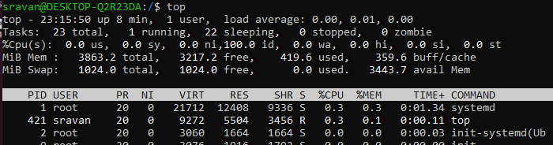

ps -ef : to get the list of running services

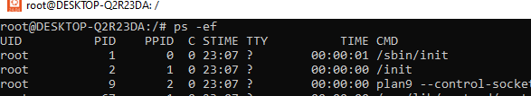

**Installing nginx or any services on Ubuntu:**

sudo apt update - Update your package index

sudo apt install nginx - to install nginx

sudo systemctl start nginx - to start nginx

sudo systemctl status nginx - to check status of nginx

sudo systemctl stop nginx - to stop nginx or any services

sudo kill -9 3583(process ID) – to kill the services

ps –ef | grep nginx : to check particular running services “nginx”

